**University of Michigan-Shanghai Jiaotong University Joint Institute**

**Alumni Resource**

**Background:**

If we assume an average student number of 250, UM-SJTU will have 1750 alumni now (from 2006 to 2012). On Linkedin, there is 500+ connections in UM-SJTU network. However, there is only 60 students who claim them as UM-SJTU JI students where we could view their living place, working position and industry.

Building an effective alumni-networking system will be an influential thing for careers of both students and alumni.

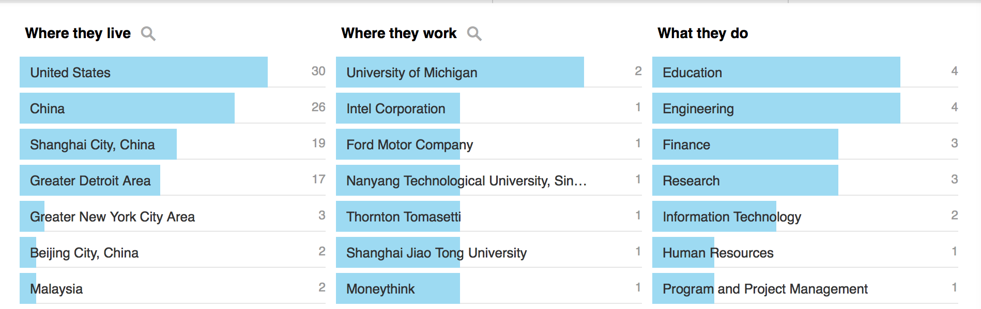

(Figure 1: LinkedIn information of UM-SJTU Alumni)

**Proposal:**

1. Build an alumni directory to record the name, contact, graduate year, current position and company.
2. Organize regular (per half year or per season) alumni
3. Build individual connections with alumni to ensure effective communication and job refer opportunity
4. Provide one-to-one coffee talk with alumni if possible

**Primary Plan**

1. With the working of 2 or 3 current students and the help from department teacher, try to first build connections with alumni that could help gather information and post motivation.
2. Build an alumni directory. Post it online for every student.
3. Since 2013 students, gather information before graduation.
4. Expand to Shanghai Jiaotong University and University of Michigan alumni if possible